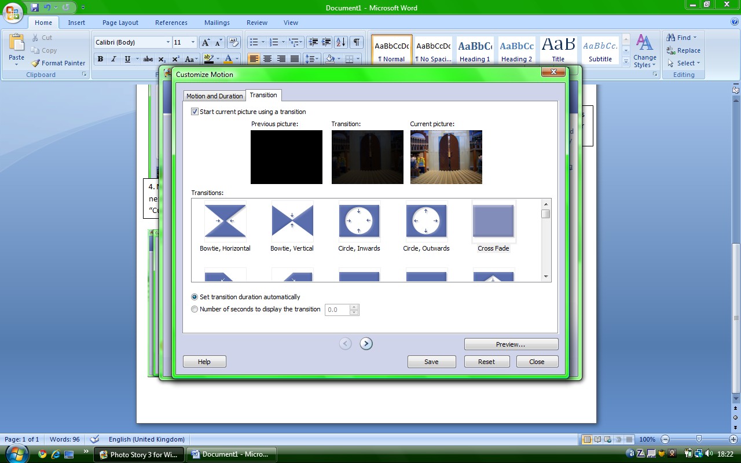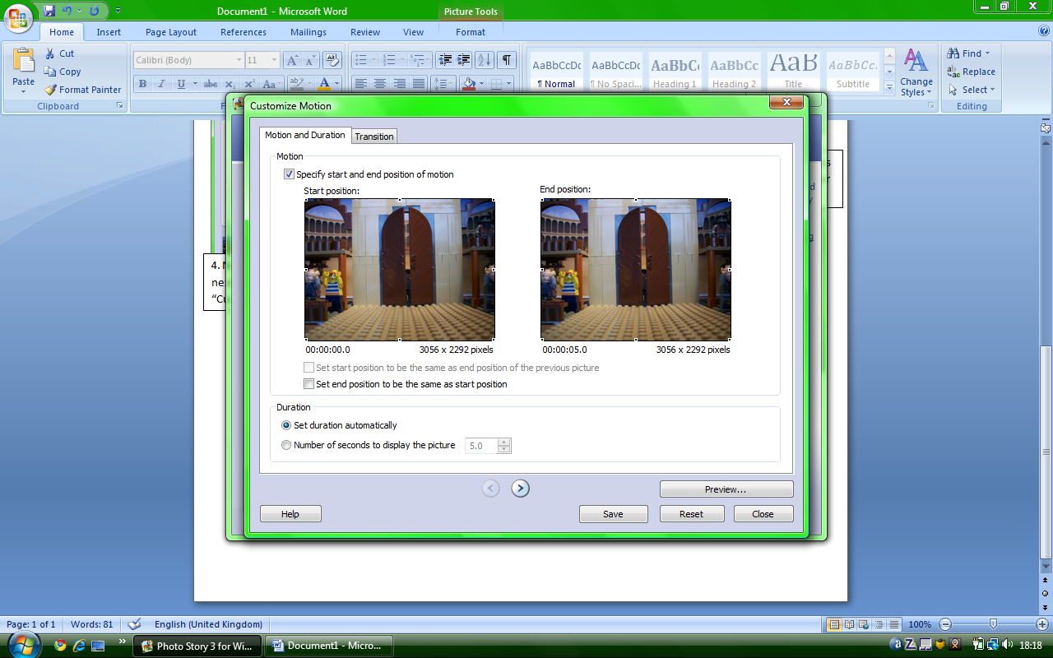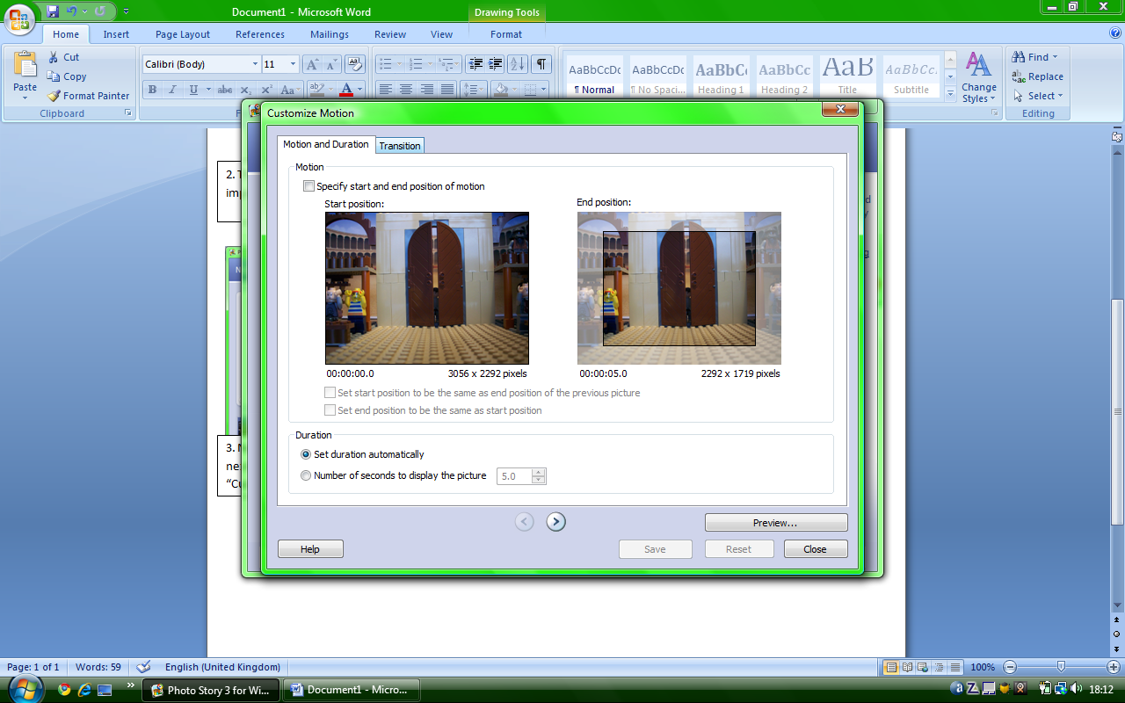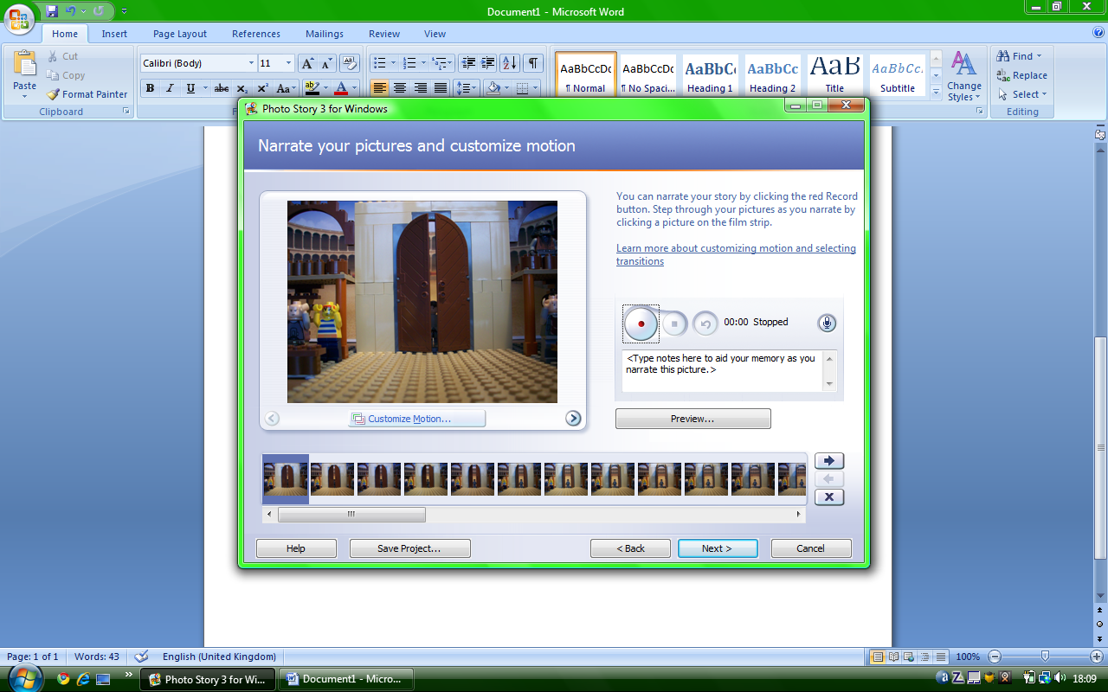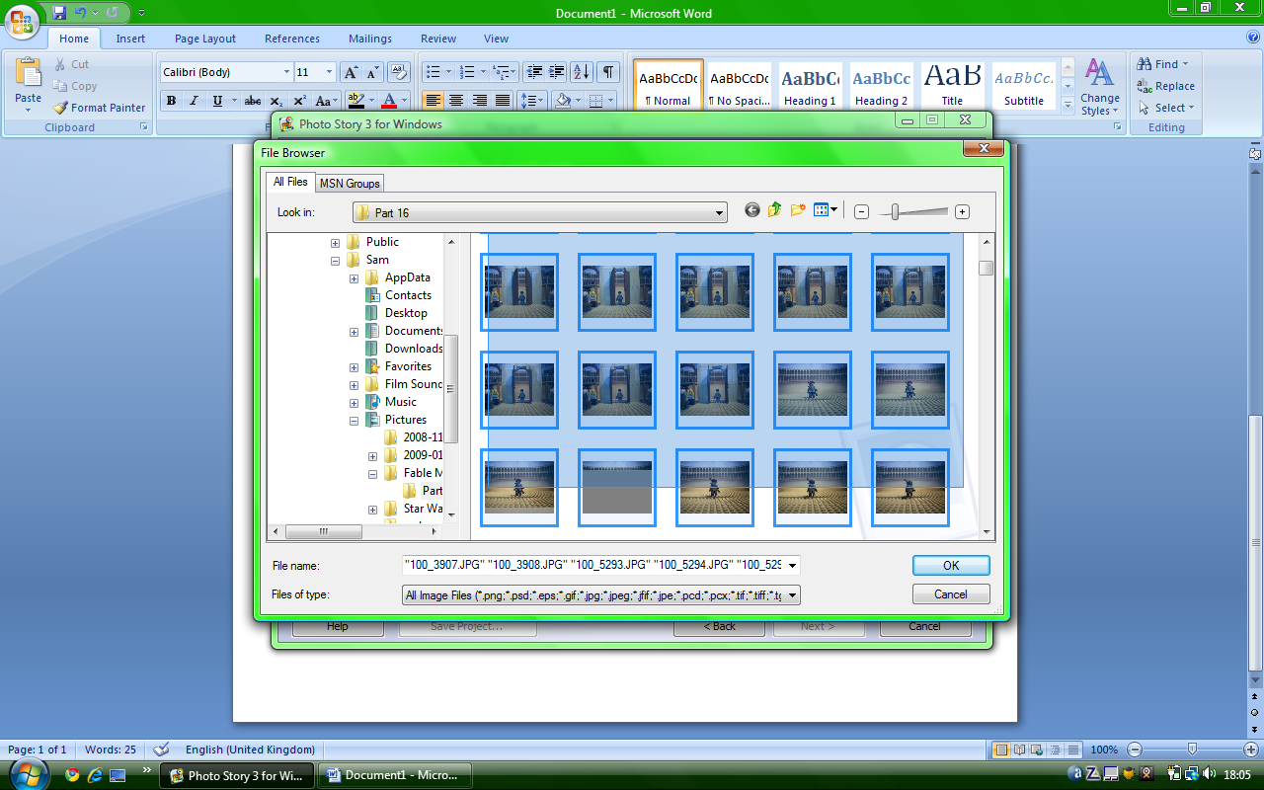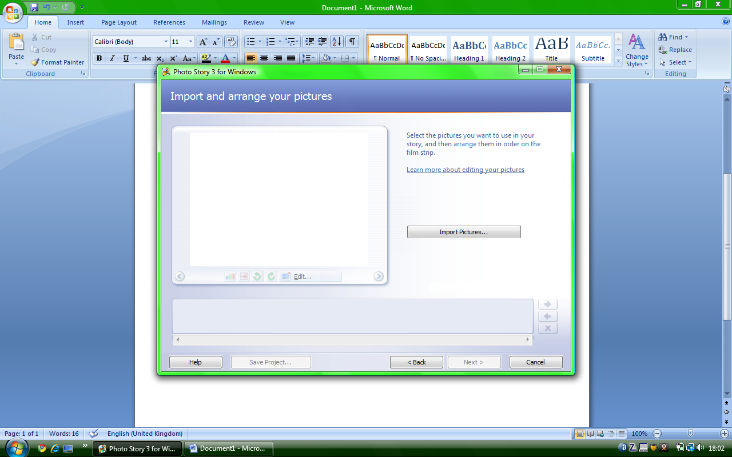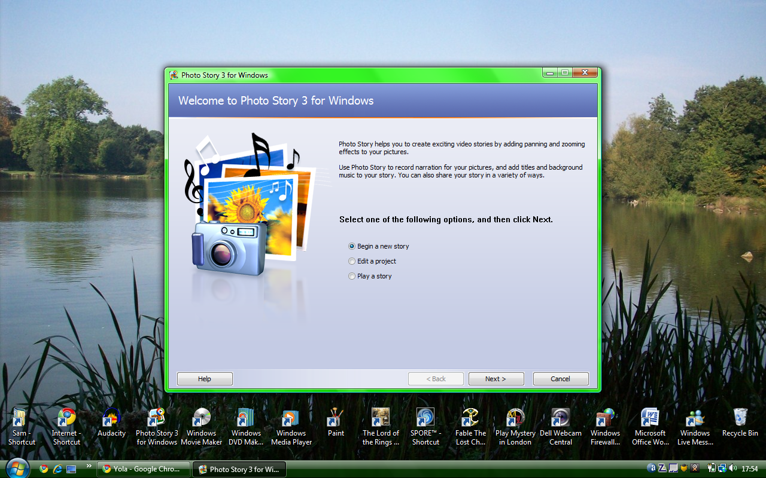

7. Un-select “Red” and click save (Yellow). Click “Green” and continue with this method until film is complete. \*\*NOTE: STORIES CAN ONLY CONTAIN A MINIMUM OF 300 PHOTOS\*\*

6. Click “Red” and type in 0.1 where it said “5.0”. Now click transition (Yellow).

5. Click “Red” and double click on the pictures which are smaller and have a washout border (e.g. “Yellow” which is smaller.)

4. Now you have your pictures, click next (Red) twice and then click “Customize motion” (Yellow).

3. The file browser will appear. Highlight the pictures you would like to use and click OK (Red)

2. This screen will appear click import pictures (Red).

1. Open your photostory 3. Select begin a new story (Red) and then click next (yellow).